# Finding Exact Values of the Trigonometric Functions Secant, Cosecant, Tangent and Cotangent

We can also define the remaining functions in terms of the unit circle with a point $(x, y)$ corresponding to an angle of $t$.

It $t$ is a real number and $(x,y)$ is a point where the terminal side of an angle of $t$ radians intercepts the unit circle, then

$$\tan{t}=\frac{y}{x}, x≠0$$

$$\sec{t}=\frac{1}{x}, x≠0$$

$$\csc{t}=\frac{1}{y}, y≠0$$

$$\cot{t}=\frac{x}{y}, y≠0$$

Examples

1. The point $\left(-\frac{\sqrt{3}}{2},\frac{1}{2}\right)$ is on the unit circle. Find $\sin{t},\cos{t},\tan{t},\sec{t},\csc{t},$ and $\cot{t}$.

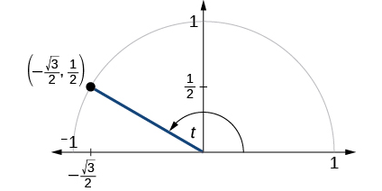

1. Find $\sin{t},\cos{t},\tan{t},\sec{t},\csc{t},$ and $\cot{t}$ when $t=\frac{π}{3}$.

# Using Reference Angles to Evaluate Tangent, Secant, Cosecant, and Cotangent

We can evaluate trigonometric functions of angles outside the first quadrant using reference angles as we have already done with the sine and cosine functions. The procedure is the same: Find the reference angle formed by the terminal side of the given angle with the horizontal axis. The trigonometric function values for the original angle will be the same as those for the reference angle, except for the positive or negative sign, which is determined by $x$ - and $y$ -values in the original quadrant.

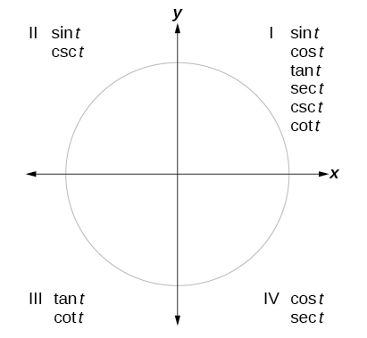

Given an angle not in the first quadrant, use reference angles to find all six trigonometric functions.

1. Measure the angle formed by the terminal side of the given angle and the horizontal axis (this is the reference angle).

2. Evaluate the function at the reference angle.

3. Observe the quadrant where the terminal side of the original angle is located. Based on the quadrant, determine whether the output is positive or negative.

Example

Use reference angles to find all six trigonometric functions of $-\frac{5π}{6}$.

# Using Even and Odd Trigonometric Functions

Recall that an even function is one in which $f\left(-x\right)=f(x)$ and an odd function is one in which $f\left(-x\right)=-f(x)$. We can test whether a trigonometric function is even or odd by drawing a unit circle with a positive and negative angle, as shown below. The sine of a positive angle is $y$. The sine of the negative angle is $–y$. The sine function, then, is an odd function. We can test each of the six trigonometric functions in the same way.

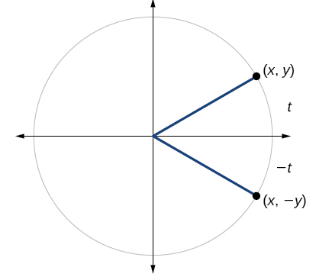

**Even and Odd Trigonometric Functions**

An even function is one in which $f\left(-x\right)=f(x)$.

An odd function is one in which $f\left(-x\right)=-f(x)$.

Cosine and secant are even:

$$\cos\left(-t\right)=\cos{t}$$

$$\sec\left(-t\right)=\sec{t}$$

Sine, tangent, cosecant, and cotangent are odd:

$$\sin\left(-t\right)=-sin{t}$$

$$\tan\left(-t\right)=-tan{t}$$

$$\csc\left(-t\right)=-ccs{t}$$

$$\cot\left(-t\right)=-\cot{t}$$

Examples

1. If the secant of angle $t$ is 2, what is the secant of $–t$?
2. If the cotangent of angle $t$ is $\sqrt{3}$, what is the cotangent of $–t$?
3. Determine whether the function $f\left(x\right)=2\sin{x}\cos{x}$ is even, odd, or neither.

# Recognizing and Using Fundamental Identities

We can derive some useful identities from the six trigonometric functions. The other four trigonometric functions can be related back to the sine and cosine functions using these basic relationships:

$$\tan{t}=\frac{\sin{t}}{\cos{t}}$$

$$\sec{t}=\frac{1}{\cos{t}}$$

$$\csc{t}=\frac{1}{\sin{t}}$$

$$\cot{t}=\frac{1}{\tan{t}}=\frac{\cos{t}}{\sin{t}}$$

Examples

1. Given $\sin{(45°})=\frac{\sqrt{2}}{2}$, $\cos{(45°})=\frac{\sqrt{2}}{2}$, evaluate $\tan{(45°})$.
2. Evaluate $\csc{\frac{7π}{6}}$.
3. Simplify $\frac{\sec{t}}{\tan{t}}$.
4. Simplify $(\tan{t})(\cos{t})$
5. If $\sin{t}=-\frac{\sqrt{3}}{2}$ and $\cos{t}=\frac{1}{2}$, find $\sec{(t)},\csc{(t)},\tan{(t)},\cot{(t)}$.

## Alternate Forms of the Pythagorean Identity

We can use fundamental identities to derive alternate forms of the Pythagorean Identity, $\cos^{2}{t}+\sin^{2}{t}=1$. One form is obtained by dividing both sides by $\cos^{2}{t}$.

$$\frac{\cos^{2}{t}}{\cos^{2}{t}}+\frac{\sin^{2}{t}}{\cos^{2}{t}}=\frac{1}{\cos^{2}{t}}$$

$$1+\tan^{2}{t}=\sec^{2}{t}$$

The other form is obtained by dividing both sides by $\sin^{2}{t}$.

$$\frac{\cos^{2}{t}}{\sin^{2}{t}}+\frac{\sin^{2}{t}}{\sin^{2}{t}}=\frac{1}{\sin^{2}{t}}$$

$$\cot^{2}{t}+1=\csc^{2}{t}$$

**Alternate Forms of the Pythagorean Identity**

$$1+\tan^{2}{t}=\sec^{2}{t}$$

$$\cot^{2}{t}+1=\csc^{2}{t}$$

Examples

1. If $\cos{(t)}=\frac{12}{13}$ and $t$ is in quadrant IV, find the values of the other five trigonometric functions.
2. If sec $=-\frac{17}{8}$ and $0<t<π$, find the values of the other five functions.

# Evaluating Trigonometric Functions with a Calculator

Evaluating a tangent function with a graphing calculator is like evaluating a sine or cosine: Enter the value and press the TAN key. For the reciprocal functions, there may not be any dedicated keys that says CSC, SEC, or COT. In that case, the function must be evaluated as the reciprocal of a sine, cosine, or tangent. Pay attention to the “mode” of the calculator to ensure it corresponds to the way the angle is represented (radians or degrees).

Examples: Evaluate the following functions using a calculator.

$\sin{43°}$

$\csc{\frac{5π}{9}}$

$\sec{\frac{3π}{4}}$

$\cot{140°}$